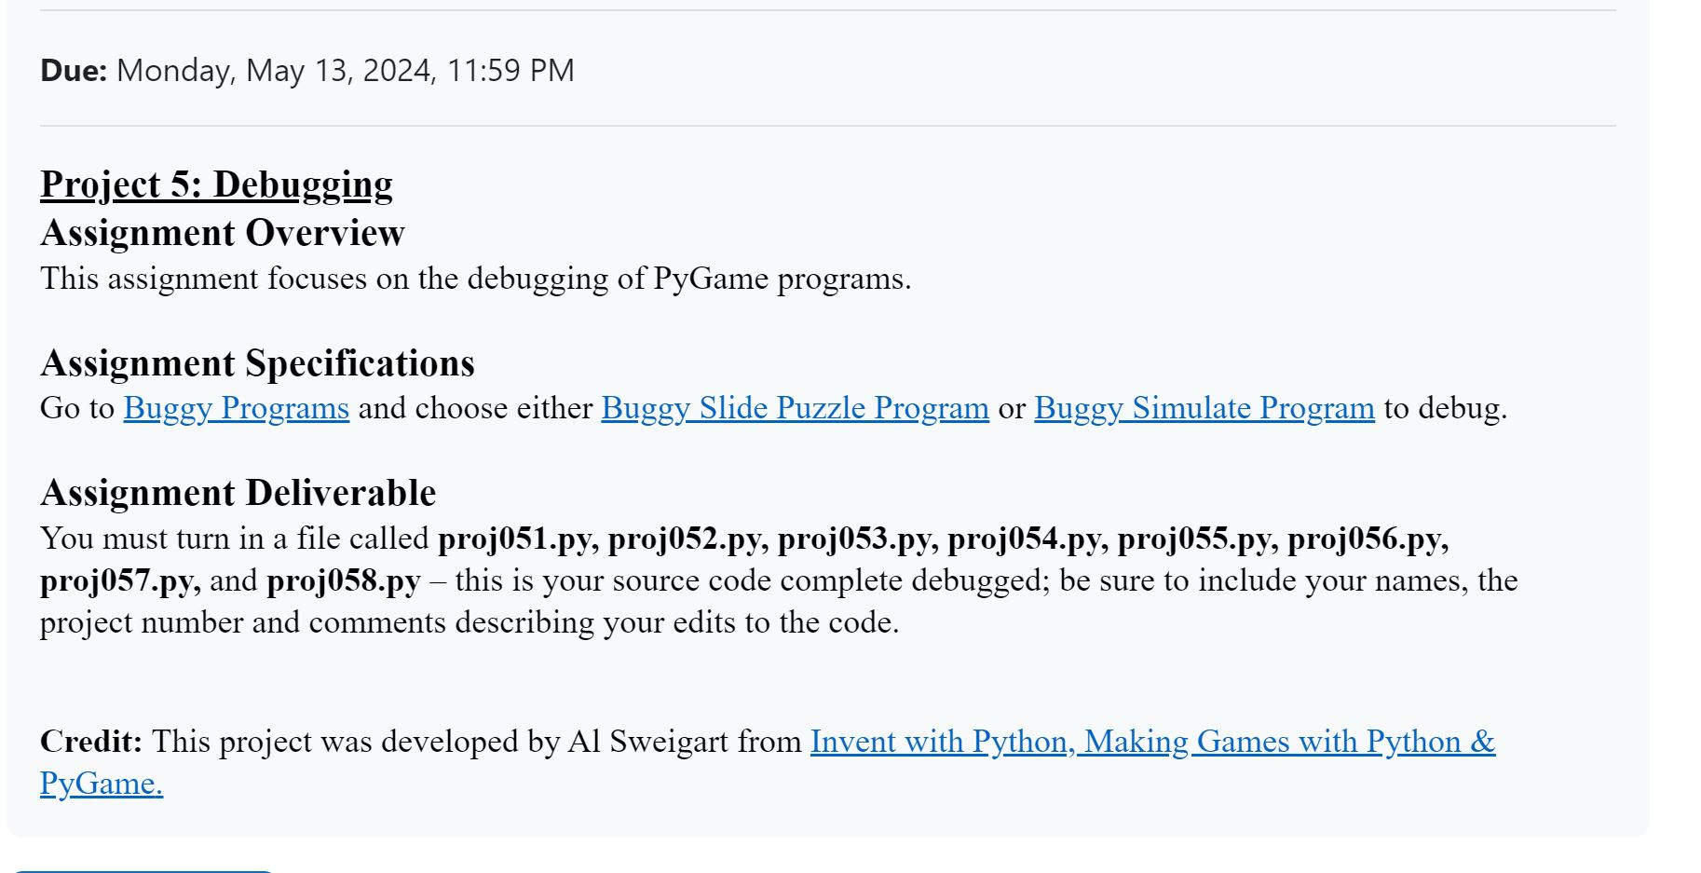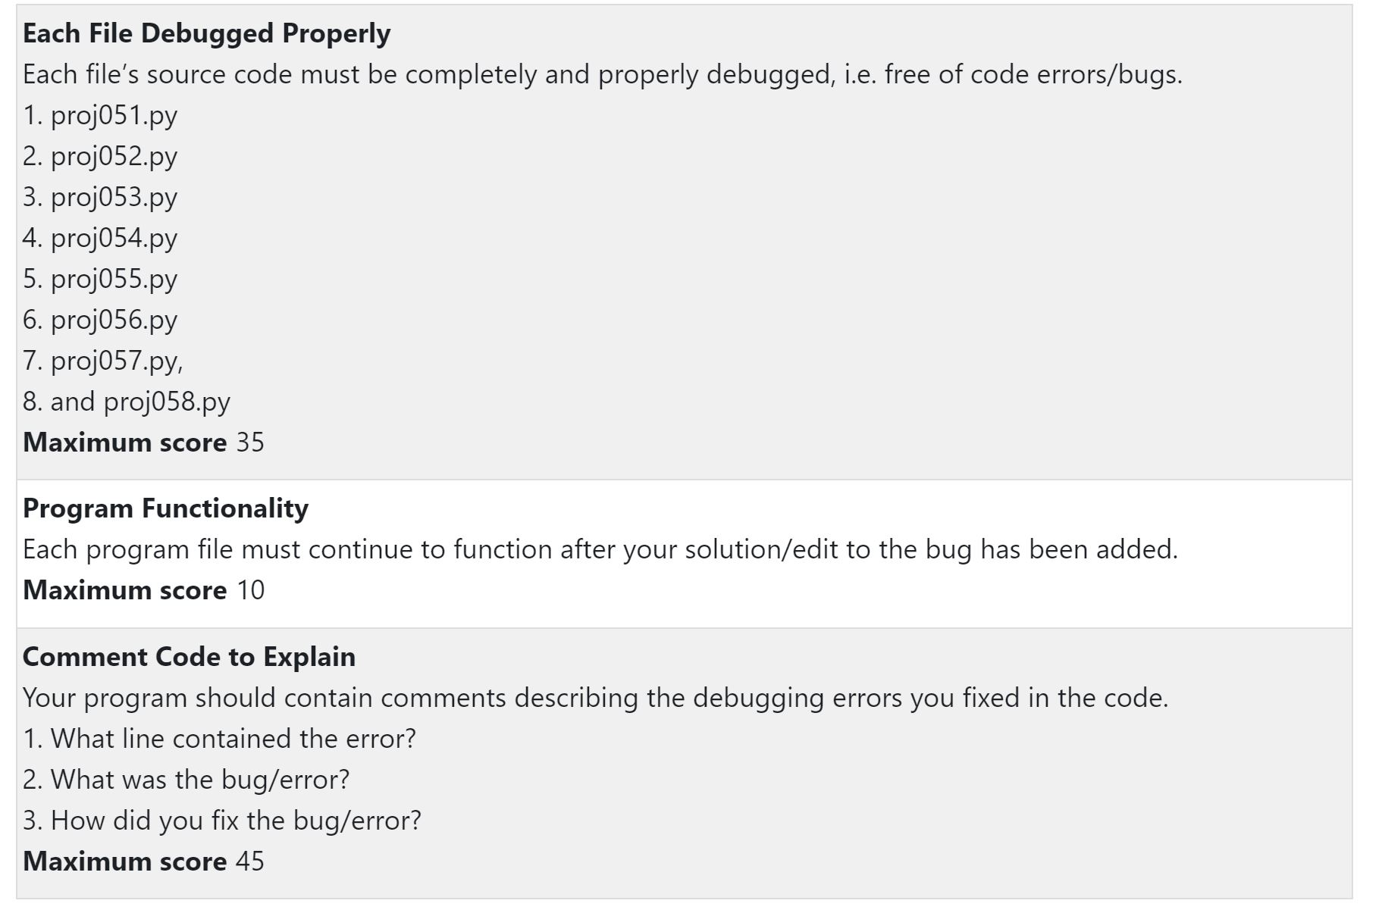Go to: <https://inventwithpython.com/pygame/buggy/>

Choose: <https://inventwithpython.com/pygame/buggy/> OR <https://inventwithpython.com/pygame/buggy/>